**7376 HW1**

**Name: Xuebao Zhao NUID: 002108354**

**Problem1:**

Function “print_args” takes the exact same arguments as function main. Then it uses a loop to traverse the array “argv” and print them one by one.

**Results:**

**Problem2:**

This program uses function “printf” to print the prompt “$”. Then it uses the function “fgets” to get the input from keyboard and store the input string into variable “ret”. When the ret is not empty, the program gets the length of the string by using function “strlen” and replace the character(‘\n’) with a null character (‘\0’). Finally put the above statements into a “while (1)”.

**Results:**

**Problem3:**

**a)**

At the beginning of the program, it creates the child process by using fork(). If folk failed, exit the program. When this program continues run, there is one parent process and one child process active in the system. The child process reads an integer value by using function “scanf” from the keyboard and returns it with an invocation of function “exit” (exit(input)). The parent process waits for the child process to finish and captures the child’s exit status (wait(&status);). Finally, parent print the equal value.

**Results:**

**b)**

Change the code in the child process. Print the pid of the child process and the parent, and repeat the above statements after sleeping for two seconds (put them in a while(1) loop). The parent process will print its own information after sleeping for 4 seconds and end.

**Results:**

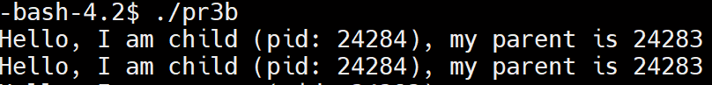

At first, the parent process and the child process are both running.

The parent process ends after 4 seconds, and the child process becomes an orphan process.

The child process (pid = 24284, name = pr3b) still exist, but the parent process cannot be found.

**c)**

Do the same thing as pr3b, but swap what is done in the child process with the parent process. The child process print the pid of the child process and the parent only once. The parent process will print its own information after sleeping for 2 seconds and repeat (put them in a while (1) loop).

**Results:**

At first, the parent process and the child process are both running.

The child process ends.

The child process is a zombie and indicated by <defunct>

**Problem4:**

Use the same method as problem2 to read a string from the user. Then extract arguments in function “get_args”. The function “get_args” defines a string “temp” to temporarily store the fragment of argument. Every time using function “strtok” to get an fragment and store it in temp. When temp is not empty, copy it to “argv” and the variable “num” which counts the number of fragments plus one. Continue until temp equals to empty.

**Results:**

